

I GIVE MY PLEDGE AS AN AMERICAN, TO SAVE AND FAITHFULLY DEFEND FROM WASTE, THE NATURAL RESOURCES OF MY COUNTRY; ITS AIR, SOILS AND MINERALS, ITS FORESTS, WATERS AND WILDLIFE. I WILL HELP EDUCATE FUTURE GENERATIONS TO BE RESPONSIBLE CARETAKERS OF THE RESOURCES OF AMERICA

NOVEMBER 2014

Volume 69 No. 11

Club Website- <http://rrgclub.tripod.com/clubhome>

Club Facebook Site – [www.Facebook.com/RichlandrodandGunClub](http://www.Facebook.com/RichlandrodandGunClub)

Northwest Game Recipes Web Site – [www.northwestgamerecipes.com](http://www.northwestgamerecipes.com)

2014-15 Officers

Kirby Hammond, Pres. 713-4668 Matt Lucas, Vice Pres. 845-1207

Richard Libby, Treas. 947-0498 Frank Scopa, Sec. 375-4748

**MEETINGS AND DEADLINES**

NOV. GENERAL MEETING—7 pm, Tuesday Nov. 4, Benton PUD, 2721 W 10th Ave, Kennewick

BOARD MEETING—7 pm, Tuesday, Nov 18, Hunter Education Facility at Griggs in Pasco

NEWSLETTER DEADLINE—Nov. 18, Call Frank Scopa at 375-4748 or secretary.rrgc@yahoo[.com](mailto:davencarol68@gmail.com)

**VOTE: Due to the significant impacts that could occur via the propositions on this year’s ballot, all members are reminded that they need to exercise their Constitutional right to vote. Voting is not a privilege but a Right, please exercise your Rights.**

**NOVEMBER MEETING:** Matt Lucas

Guest speakers for the November 4 meeting will be Steve Schulz, a local duck and goose guide. Mr. Schultz will make a presentation for the 2014 season. Also, Mr. Greg Detloff will provide a ten minute presentation about preparing your dog for the upcoming season. Richard Sharp, will have a selection of appropriate door prizes to accentuate the topics being covered. The meeting will be held at the Benton PUD building off 10th Avenue in Kennewick at 7:00 PM.

**DOOR PRIZES:** Richard Sharp was able to provide 15 door prizes for the October meeting. The winners were as follows; Chris Mosher won the Katch Cooler and the 9 inch Rapala fillet knife, Mike Becker won the Game Hoist, John Prather won the Camo Seat Cushion and one of the customized Dual Bucket Seats, Josh Hoover won both the 5 lb Axe and the Hatchet, Fay Lyon won the Steelhead Fishing Kit, Rick Libby won one of the Salmon Super Flasher Kits, Eric Nyberg won the second Salmon Super Flasher Kit and the second customized Dual Bucket Seat, Matt Cummings won the third Salmon Super Flasher Kit, Bill won the Bushnell Binoculars, Kirby Hammond won the Machete and Steve Shankle won the Mystery Box. As per the custom of the RRGC monthly meetings, visitors receive five free tickets to the door prize raffle.

**BULLETIN HELP:** Frank Scopa

If you are receiving this bulletin via U.S. Mail and you have an email account, please drop a note to Frank Scopa at [secretary.RRGC@yahoo.com](mailto:secretary.RRGC@yahoo.com) with your email address. Printing and mailing costs are eating into the club’s ability to carry on our stated goals (see pledge above). Your help is greatly appreciated. If you have anything you would like to have included in the monthly newsletter, contact me at the e-mail address above.

**In Memoriam:** Arlen Schade

The Richland Rod and Gun Club offers its condolences on the passing of long time member Arlen Schade on September 23, 2014 at the age of 72.  Arlen joined the Club in 1972 and received the 25 year Buckle Award in 1997.  Although Arlen relocated from the Tri-City area a number of times, he kept his membership active.  He loved to hunt and fish, and over the years between him and his hunting partner Jerry Bloom, won the Club’s Quality Trip five times: two for trophy Whitetail deer hunting once in Missouri and again in Tennessee , one for bear hunting in British Columbia, one for archery elk in Montana and one for Barbary sheep in Texas. Arlen won another trip for moose in Northwest Territory and went with Chuck McCargar.  Arlen also achieved a Grand Slam in Turkeys.  Arlen is best remembered for his always entertaining stories he told with great enthusiasm.

This tribute was written by Jerry Bloom and Howard Gardner. Arlen was living in Tennessee when he passed.

**TREASURER’S REPORT:** Richard Libby

Rick Libby’s Treasurer’s Report continues to balance on a monthly basis. There was an expenditure within the Hunter’s Education Funds for two Mossberg youth 20 gauge pump shotguns. These were purchased from the Hunters Education funds.

**BIG GAME BANQUET:** Gene Van Liew

The March 2015 and March 2016 Banquet dates have been locked in with the Columbia River Trading Company located at the Shiloh Inn in Richland. Kirby Hammond is in discussions with a potential guest speaker for the 2015 banquet. Any suggestions for or points of contact with potential speakers should be forwarded to Kirby at 713-4668.

**SALMON IN THE CLASSROOM:** Gene Van Liew (this is a repeat from last month)

The 2015 Salmon in the Classroom program has suffered considerable budget reductions. The Salmon Summit and Classroom activities will continue. However, the biggest hit will be to in-classroom dissections, where Benton Conservation District personnel will no longer be available; dissections will be performed by individual teachers, with RRGC assistance if requested. The BCD will provide training to teachers to help them carry on. Gene has committed to assist with delivery of supplies; however tank setup and tear down will have to be done by individual teachers. These teachers are dedicated individuals, but this additional burden may tax them beyond their ability to keep the program going. Additional Rod and Gun Club volunteers may well be needed to provide setup and tear down assistance.

**HUNTER EDUCATION:** Ron Ruth/Dave Myers

The next Hunter’s Education will be held in late winter/early spring. Contact Ron Ruth or Dave Myers for further information. Ron can be reached at 509-628-1781 and Dave at 509-438-1277.

**GAME RECOVERY:** Chris Mosher

Two does were recovered on Sunday, October 19th. The does were recovered on Hwy 124 at the 15.5 mile marker. There was well over 100 pounds of meat recovered and turned over to the Union Gospel Mission. Thanksgiving is coming up soon and a reminder that the Union Gospel Mission is always in need of food donations.

**VOLUNTEER ASSISTANCE:** Dale Schielke (a repeat from last month)

Ringold Hatchery Volunteers Needed

It was noted that anytime a RR&GC member donates their time to WDFW efforts, they need to ensure that their hours are recorded. Per direction received from WDFW, the following is now how donated efforts will be tracked:

The Richland Rod and Gun Club entered into a cooperative agreement with WDFW to provide 2000 trout for Lunker Lake in exchange for 100 volunteer hours at the Ringold Hatchery.   Volunteers are needed to assist WDFD hatchery staff man the fish trap on Thursdays starting September 18th.  Duties may include catching fish in the trap so they can be sexed then vital data collected/recorded.  Activities will start about 9 am and last for 2 to 4 hours depending upon the number of fish.  The work is fairly strenuous and waders and rain suit will be needed, but WDFW will provide them.  There may be other activities at the hatchery where volunteers can assist.  Ideally 2 to 3 volunteers are needed on most Thursdays and if someone wants to help on a fairly regular basis they could be a lead volunteer that can “train” other volunteers that have not helped prior.  If you are interested in volunteering, please call Dale Schielke, he will coordinate the volunteers and possible car pool.   All volunteers need to be registered in the WDFW CERVIS system and then record/log their volunteer hours in the system.  Register to volunteer at <http://wdfw.wa.gov/about/volunteer>  Fill out the form and check “Richland Rod and Gun Club” in the volunteer group section near the bottom of the form.  After receiving your password back from WDFW you will be able to login and register for the event “Apr 1, 2014 Ringold Springs Hatchery Volunteers”   Under search volunteer database , search for your name.  Then click on the icon in front of your name for “Register for and Event” Click on “Apr 1, 2014 Ringold Springs Hatchery Volunteers” then the register button.  Hours are entered using the icon “Log Service Project Activity for….”  Call Dale Schielke 375-0183 with issues registering, entering hours, or if you need him to upload your data (no computer or you are not computer savvy).

At the present time, RRGC is approximately half way to the goal of 100 volunteer hours. The volunteer hours will be applied to offset the cost of the Lunker Lake trout. There are photos and videos on the RRGC Facebook Page for viewing. Additional volunteers are needed on Thursdays. (If you haven’t volunteered, it is interesting – Secretary’s note.)

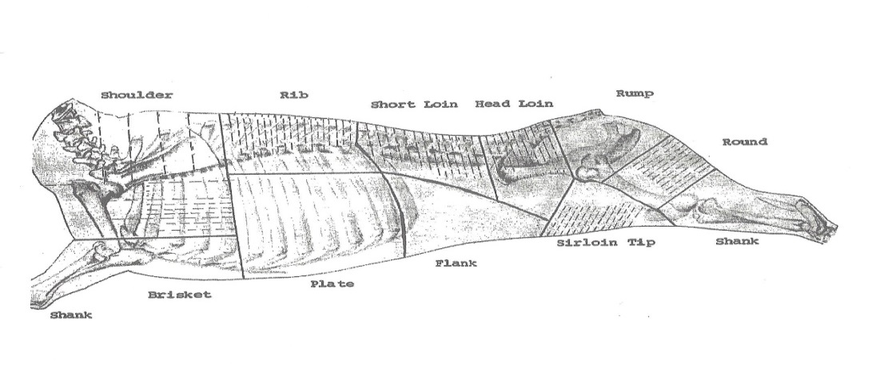

**Standard Meat Cuts**

**Meat Donations:**

As per last year, John Prather has graciously volunteered his freezers for meat donations storage for the Big Game Banquet. Each donation should be tagged with the following information; Donor’s name, species and cut of meat, plus the date taken. John can be reached at 509 582-2482.

**Youth Hunt:** Daxton Cummings was nominated for the Barker Ranch Youth Hunt. The hunt will be on the 8th of November. Contact Mike Estes is you would like additional information regarding future Youth Hunts. Mike can be reached at 509-551-9066.

**New Members:** Please welcome

Josh Hoover of Burbank, WA

Regan and Amelia Hurlbert of Benton City

Robert Zylman of Richland

**Richland Rod & Gun Club**

**PO Box 337**

**Richland, WA 99352-0337**

**RETURN SERVICE REQUESTED**

**Last Items:**

Classified Ad – Rifle For Sale

Winchester Model 70 Featherweight, “pre-64” (manufactured in 1953), 308 Win caliber, Redfield mounts, Hertel & Reuss 4x81 scope.  Used but in very good condition and comes with sling, and partial box of ammo.   $700.00  Contact Dale Schielke 375-0183