

I GIVE MY PLEDGE AS AN AMERICAN, TO SAVE AND FAITHFULLY DEFEND FROM WASTE, THE NATURAL RESOURCES OF MY COUNTRY; ITS AIR, SOILS AND MINERALS, ITS FORESTS, WATERS AND WILDLIFE. I WILL HELP EDUCATE FUTURE GENERATIONS TO BE RESPONSIBLE CARETAKERS OF THE RESOURCES OF AMERICA

OCTOBER 2014

Volume 69 No. 10

Club Website- <http://rrgclub.tripod.com/clubhome>

Club Facebook Site – [www.Facebook.com/RichlandrodandGunClub](http://www.Facebook.com/RichlandrodandGunClub)

Northwest Game Recipes Web Site – [www.northwestgamerecipes.com](http://www.northwestgamerecipes.com)

2014-15 Officers

Kirby Hammond, Pres. 396-7723 Matt Lucas, Vice Pres. 845-1207

Richard Libby, Treas. 947-0498 Frank Scopa, Sec. 375-4748

**MEETINGS AND DEADLINES**

OCT. GENERAL MEETING—7 pm, Tuesday Oct. 7, Benton PUD, 2721 W 10th Ave, Kennewick

BOARD MEETING—7 pm, Tuesday, Oct 21, Hunter Education Facility at Griggs in Pasco

NEWSLETTER DEADLINE—Oct. 18, Call Frank Scopa at 375-4748 or fvscopa@yahoo[.com](mailto:davencarol68@gmail.com)

**OCTOBER MEETING:** Matt Lucas

Guest speakers for the September 2, meeting will be both Paul Hoffarth, representative of the WDFW, who will present what is in store for the fall salmon run on the Columbia, as well as Club member Matt Cummings who will discuss fishing at Buoy 10 on the Columbia River. Richard Sharp, will have a selection of appropriate door prizes to accentuate the topics being covered. The meeting will be held at the Benton PUD building off 10th Avenue in Kennewick. Twelve Door Prizes were raffled off. Chris Mosher took over Richard Sharp’s duties. Jim Cartmell won the 8’ Salmon Rod and the RMEF Buck Knife, Matt Cummings won a Buck knife, Paul Kison won a Tuna Ball kit, Mike Becker won a Steelhead bait rig outfit, Chris Mosher won the 5 gallon bucket with a swivel seat (custom paint job on the bucket), Larry Martin won the 3 gallon bucket with a swivel seat (another custom paint job on the bucket), Chris Mosher won the 12 inch Dutch Oven, Scott Strickland won the camp ax, Dave Myers won the deer hoist, Matt Lucas won the salmon net, Bob Zylman won the donated knife and 550 cord.

**BULLETIN HELP:** Frank Scopa

If you are receiving this bulletin via U.S. Mail and you have an email account, please drop a note to Frank Scopa at [secretary.RRGC@yahoo.com](mailto:secretary.RRGC@yahoo.com) with your email address. Printing and mailing costs are eating into the club’s ability to carry on our stated goals (see pledge above). Your help is greatly appreciated.

**EDDIE MANTHOS TRIBUTE:**

A tribute to Eddie Manthos is posted on the RR&GC Facebook page. The tribute was written by Howard Gardner and speaks of the longtime relationship that Eddie had with RR&GC. He is greatly missed. His sense of purpose, abilities and attitude will not be easily replaced.

A donation for $25 in Eddie’s name was made to the Tri-Cities Chaplaincy from RR&GC.

Kirby Hammond has suggested that an annual volunteer award given in Eddie’s name. The idea would be to recognize the efforts of RR&GC’s younger/newer members that have demonstrated an effort to support our efforts through their voluntary involvement. It was decided that the Awards Committee would address this further.

**TREASURER’S REPORT:** Richard Libby

The Coca-Cola bill from the Salmon Booth was paid during this past month. All accounts for the salmon booth have been settled. The profit reported earlier remains the same since the Coca Cola invoice was included in the previous costs. For those that don’t recall, the profit was $3,927.36 for both Columbia Fly Fishers and Richland Rod and Gun Club.

**BIG GAME BANQUET:** Gene Van Liew

It was reported that O’Callahan’s Restaurant has had a name change. As a result, the Big Game Banquet will continue to be at the Shiloh Inn but the restaurant/dining room will be called Columbia River Catering Company. The date of the 2015 Big Game Banquet is March 28, 2015. Gene Van Liew was directed by the Board to lock in a reservation for the 2016 Big Game Banquet. The 2016 date will be March 19, 2016.

A reminder to all that with hunting season now upon us it is time to start stockpiling the critical entrées for the Banquet. The location for the storage of the cuts of meat will be sent out in next month’s newsletter.

Kirby Hammond is researching and has started discussions with a potential guest speaker for the 2015 Banquet. Any suggestions for or points of contact with potential speakers should be forwarded to Kirby at 396-7723.

**GUZZLERS:** Larry Martin

The recent fires in the region have destroyed or severely damaged several guzzlers near Prosser. Three guzzlers were destroyed by fire and three more were damaged. In addition, there are many other guzzlers that are in need of repair/maintenance. Two tanks with tops were located at Windmill Ranch WMA and were donated for the guzzler program. It was brought up that the budget contained $500 under Use of Funds that was to be split between the guzzlers and wood duck boxes. As a part of the guzzlers program, the Board was informed that the local representation of WDFW would prefer direct purchase of materials in lieu of donations to the general WDFW funds. Expenditures in this manner will allow for RR&GC funds to be spent in a more efficient and directed manner.

**SALMON IN THE CLASSROOM:** Gene Van Liew

The 2015 Salmon in the Classroom program has suffered considerable budget reductions. The Salmon Summit and Classroom activities will continue. However, the biggest hit will be to in-classroom dissections, where Benton Conservation District personnel will no longer be available; dissections will be performed by individual teachers, with RRGC assistance if requested. The BCD will provide training to teachers to help them carry on. Gene has committed to assist with delivery of supplies; however tank setup and tear down will have to be done by individual teachers. These teachers are dedicated individuals, but this additional burden may tax them beyond their ability to keep the program going. Additional Rod and Gun Club volunteers may well be needed to provide setup and tear down assistance.

**ATOMIC SALMON DERBY:** Dale Schielke

This salmon derby was held September 19, 20, 21. Earnings from this event are turned back into the community to help with youth-oriented outdoor activities. Plans for this year are to supplement funding for the Salmon in the Classroom. In the past, funds have been used to help with the Kid’s Outdoor Experience fishing day at Columbia Park Pond. The club helped out with the awards banquet/BBQ near the Howard Amon Park boat ramp on the 21st. Ice Harbor Brewing is donating the chicken for the BBQ. Columbia River Catering Company is donating baked beans and cobbler, and Didier Farms donated corn. Special thanks to the volunteers that helped - LouAnn Schielke, Frank Scopa, Dave Myers, Carol Myers, Jack Pickard, Jerry Caprio, Jeff Fulks, Margaret Fulks, Richard Sharp,Gene VanLiew, and Leila Brown. All attending enjoyed Chicken-ala-traeger, corn on the cob, Cesar salad, baked beans,mini croissants, and peach or blueberry cobbler. Thanks also to Bob Kolowith for his photography.

**DUCK CONSERVATION DAY:** Dale Schielke

The annual McNary Refuge Duck Conservation Day was held on September 13th. Volunteers from the Club help man several of the exhibits. Exhibits included: Wood Duck Nesting boxes, Firearm Safety, Retriever Demonstrations, Decoys, Duck Identification and others. 26 mallards and 2 teal were banded? Approximately 50 kids and 50 adults were present. Door presents were given out.

**HUNTER EDUCATION:** Ron Ruth/Dave Myers

The Youth Pheasant Hunt was held on 27 September. The hunt started out at the Connell Gun Club to shoot and, hopefully, improve the capabilities of the student hunters. The group then moved to Limits Game Farm for the actual hunt. Ten student hunters participated in the hunt.

A new Hunter’s Education Class started 17 September and finished up on 29 September. Range day was held at the Silhouette Range on Kahlotus Highway on the 20th.

**GAME RECOVERY:** Chris Mosher/Larry Martin

Chris received a call several hours after a bull elk was hit on Hwy 240. Given the time it took to get the kill reported, and the temperature of the day, recovery was not attempted. Larry Martin, Bruce Wade and Bob Kolowith recovered an elk that had to be put down by WDFW on the 19th of Sept. The elk was in danger of be pulled into a siphon under Hwy 395 and drowned. The elk was later pulled from an irrigation canal in Eltopia with WDFW equipment. Approximately 300 pounds of meat was recovered and turned over to the Union Gospel Mission. Larry Martin reported that on the 23rd of Sept, a call was received regarding a spike buck near the Ringold Hatchery. The buck was found to be sick and the meat was not recoverable.

**VOLUNTEER ASSISTANCE:** Dale Schielke/Jack Pickard

Ringold Hatchery Volunteers Needed

It was noted that anytime a RR&GC member donates their time to WDFW efforts, they need to ensure that their hours are recorded. Per direction received from WDFW, the following is now how donated efforts will be tracked:

The Richland Rod and Gun Club entered into a cooperative agreement with WDFW to provide 2000 trout for Lunker Lake in exchange for 100 volunteer hours at the Ringold Hatchery.   Volunteers are needed to assist WDFD hatchery staff man the fish trap on Thursdays starting September 18th.  Duties may include catching fish in the trap so they can be sexed then vital data collected/recorded.  Activities will start about 9 am and last for 2 to 4 hours depending upon the number of fish.  The work is fairly strenuous and waders and rain suit will be needed, but WDFW will provide them.  There may be other activities at the hatchery where volunteers can assist.  Ideally 2 to 3 volunteers are needed on most Thursdays and if someone wants to help on a fairly regular basis they could be a lead volunteer that can “train” other volunteers that have not helped prior.  If you are interested in volunteering, please call Dale Schielke, he will coordinate the volunteers and possible car pool.   All volunteers need to be registered in the WDFW CERVIS system and then record/log their volunteer hours in the system.  Register to volunteer at <http://wdfw.wa.gov/about/volunteer>  Fill out the form and check “Richland Rod and Gun Club” in the volunteer group section near the bottom of the form.  After receiving your password back from WDFW you will be able to login and register for the event “Apr 1, 2014 Ringold Springs Hatchery Volunteers”   Under search volunteer database , search for your name.  Then click on the icon in front of your name for “Register for and Event” Click on “Apr 1, 2014 Ringold Springs Hatchery Volunteers” then the register button.  Hours are entered using the icon “Log Service Project Activity for….”  Call Dale Schielke 375-0183 with issues registering, entering hours, or if you need him to upload your data (no computer or you are not computer savvy). 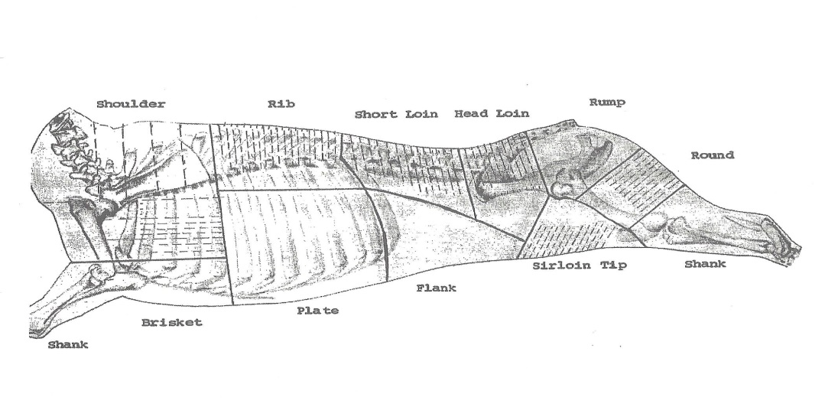

**Standard Meat Cuts**



**Last Items:**

Columbia Park Pond

WDFW has released 500 channel catfish in Columbia Park Pond.  The 5” to 6” fish will supplement the natural spawning of the brood stock released in the pond in 2012 and 2013 as part of the RRGC Catfish Derby.

Classified Ad – Rifle For Sale

Winchester Model 70 Featherweight, “pre-64” (manufactured in 1953), 308 Win caliber, Redfield mounts, Hertel & Reuss 4x81 scope.  Used but in very good condition and comes with sling, and partial box of ammo.   $700.00  Contact Dale Schielke 375-0183