

I GIVE MY PLEDGE AS AN AMERICAN, TO SAVE AND FAITHFULLY DEFEND FROM WASTE, THE NATURAL RESOURCES OF MY COUNTRY; ITS AIR, SOILS AND MINERALS, ITS FORESTS, WATERS AND WILDLIFE. I WILL HELP EDUCATE FUTURE GENERATIONS TO BE RESPONSIBLE CARETAKERS OF THE RESOURCES OF AMERICA

JANUARY 2015

Volume 70 No. 1

Club Website- <http://rrgclub.tripod.com/clubhome>

Club Facebook Site – [www.Facebook.com/RichlandrodandGunClub](http://www.Facebook.com/RichlandrodandGunClub)

Northwest Game Recipes Web Site – [www.northwestgamerecipes.com](http://www.northwestgamerecipes.com)

2014-15 Officers

Kirby Hammond, Pres. 396-7723 Matt Lucas, Vice Pres. 845-1207

Richard Libby, Treas. 947-0498 Frank Scopa, Sec. 375-4748

**MEETINGS AND DEADLINES**

JAN. GENERAL MEETING—7 pm, Tuesday Jan 6, Richland Public Library, 955 Northgate Drive, Richland

BOARD MEETING—7 pm, Tuesday, Jan 20, Hunter Education Facility at Griggs in Pasco

NEWSLETTER DEADLINE—Jan.18, Call Frank Scopa at 375-4748 or secretary.rrgc@yahoo.com

**JANUARY MEETING:** Matt Lucas/Kirby Hammond

The speaker will be Tom Moore. His topic will be winter walleye. His talk will discuss cold water presentations and the differences between winter and summer fishing. Mr. Moore has given previous presentations to RR&GC and has always provided a significant amount of information. He can be reached at 509 713 4668.

**JANUARY MEETING:**  Kirby Hammond

We will be moving the site of the general meetings! Starting January 6, 2015 the club general meetings will be held in the Richland Public Library, 955 Northgate Drive (just south of Swift Ave, near the Federal Building.) Members living near the Richland Public Library are asked to arrive at 6:30PM in order to set up the room for the meeting. Time will be of the essence since our meeting and room clean-up must conclude by 9:00 PM.

**DECEMBER MEETING RECAP:** Dave Myers

Our December speaker was TJ Hester, a local fishing guide. He has been fishing the local region for several years and recently (6 mo) became a full-time guide, working the Columbia and Snake Rivers. He has been quite successful and the key that he has found to working the big water of the Columbia is to break it down into small areas and make those areas “small water”. He covered numerous aspects of fishing the open areas of the Hanford Reach for steelhead. He made special note that even though we are fishing in the winter, these steelhead are summer-run fish; and they respond differently than those winter run fish that are found in coastal rivers.

The flow of the Columbia through the Hanford Reach is controlled by Priest Rapids Dam, and water flow downstream at Ringgold follows the releases at the dam with a delay of about eight (8) hours. To know what the conditions at Ringgold will be go to: <http://waterdata.usgs.gov/wa/nwis/uv/?station=12472800>. This can be accessed on either a computer or a smartphone. TJ noted that steelhead tend to move and bite during periods dropping water flows. He likes to fish where the water is moving at a slow to moderate walking speed. A clue: boulder fields are like heaven, when it comes to finding steelhead, conversely sand is more like hell. Look for current breaks, the fish will likely be there. Exposed boulders, or even those mounds that the fall bank fishermen build to hold their rods, will hold steelhead when the water is up. If the water surface has ripples that are 4 to 6-inches high, you may have found nirvana.

He uses a superline line Nano-braid from Berkeley (17#), it has no stretch and unlike braided lines it flows smoothly through the rod’s guides making casting far easier. He uses a “pinky-length” piece of 3/16-inch lead wire rigged to slip above the leader. His leader is an arm’s length long, the leader is 12# Maxima Green with a #2 Octopus hook tied with an egg loop, ahead of the hook is a #10 corky. On the hook is a red shrimp. Cast upstream at about a 45o angle, by the time the rig hits bottom it should be almost abeam the boat or slightly upstream. If you get a take, set the hook with a vengeance.

Water temperature can play a role too; above 57o F, TJ uses eggs, below he uses shrimp.

Side drifting covers much water and increases the probability of finding a fish.

Bobber fishing works well where the water is a bit slower, like between large boulders where you cannot take a boat. Use a long rod (9 ft plus), rig (from the rod tip) with a bobber stop, small bead, #10 corky, bobber, ¼ oz egg sinker another bead and a barrel swivel, the leader is an arm’s length log with a jig, tipped with shrimp. Favorite jigs are a combination of red/black/white, although other colors also work.

Twelve door prizes were raffled off Rick Libby took a gift card as did Chris Mosher, Matt Lucas was a big winner, taking home a rod rack, a pair of 10x50 binoculars and two boxes of shotshells. Josh Hoover went home with a steelhead rod (with set-ups) and a tackle satchel Regan Hurlbert took home a Savortooth metal detector and Duffy took home a Field Dress Tool (Knife) Chris Mosher got the mystery box which contained a moose-head hat (He said his kids will love it).

**BULLETIN HELP:** Frank Scopa

If you are receiving this bulletin via U.S. Mail and you have an email account, please drop a note to Frank Scopa at [fvscopa@yahoo.com](mailto:fvscopa@yahoo.com) with your email address. Printing and mailing costs are eating into the club’s ability to carry on our stated goals (see pledge above). Your help is greatly appreciated. There are six e-mail addresses on our roster that have issues that result in undelivered newsletters. I will send out a request for correction this next month.

**NEW MEMBERS:** Jen Gardner, three new members were voted on and accepted by the Board. The new members are; Bill Edelblute (individual), Kennewick, Donald Scott (individual), Benton City and Tom Meagher (family), Kennewick. Please provide a warm welcome to them when you meet them at the next meeting.

**TREASURER’S REPORT:** Richard Libby, the use of funds line items and amounts were discussed and voted on during the Board Meeting held on December 16th.

**NEXT BOARD MEETING:** January 20th, 7:00PM, Griggs Hunters’ Education Room, Pasco. All RR&GC members are invited to attend.

**BIG GAME BANQUET:** Dave Myers

A reminder to all that with hunting season now upon us it is time to start stockpiling the critical entrées for the Banquet. Bring any meat donations to either a general meeting or a board meeting, we will transport them to our storage location. John Prather has generously offered freezer space at his home in Finley. A sign-up sheet will be available at the January club meeting. Included with the cuts of meat diagram, is a form to be filled out and attached to all game meat donations. This is a WDFW requirement.

**Standard Meat Cuts**

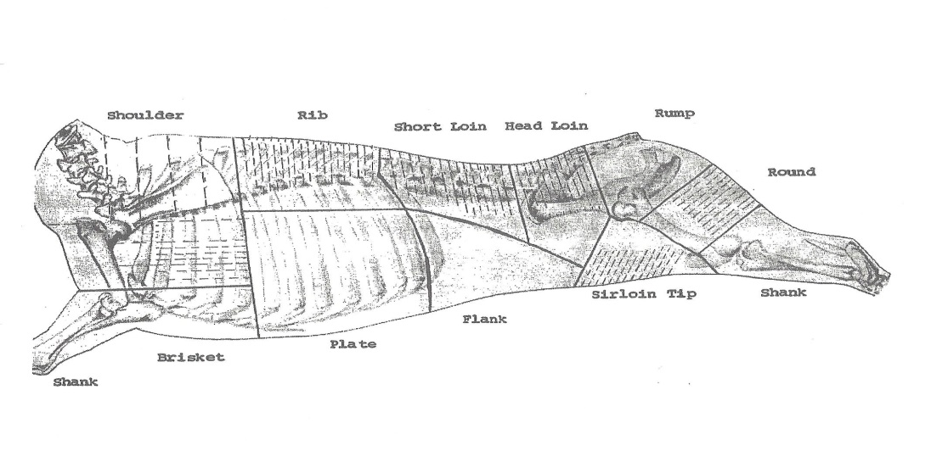

All cuts of big game should be boneless, please no ground meat. Ideally, game birds should also be de-boned. Fish should be provided either frozen in water, or as vacuum packed and frozen.

**Information to be provided for all game meat donations indicating permission for the possession of game meat: Name of donor, address of donor, hunting/fishing license number, permit or tag number, the number and kind of animal provided, the date killed, the county and area in which taken and the hunter/fisherman’s signature.**

**GAME RECOVERY:** Chris Mosher/Larry Martin/Dave Myers

Richland Police Dept called Larry Martin regarding a two point mule deer that had been hit by a car on Leslie Road in Richland. Larry, his grandson Bryce and Dave Myers picked up the deer and moved it to a safer location in order to gut the animal. Larry then took it home to debone the meat. Approximately 35 pounds of meat was turned over to the Union Gospel Mission in Pasco.

**CORN STUBBLE ACCESS PROGRAM**

The following was provided by Ryan Stutzman of WDFW. Below is a quick write up about the Corn Stubble access program. The sites in Region 2 and 3 are all “Hunt By Online Reservation” only but they transition to “Register to Hunt” if the site is unoccupied at 8 AM and are only open on goose days, regardless of species. This was done to ensure a quality hunt while maximizing opportunity. Please let your guys and gals know that they can contact me with any questions.

WDFW has continued working to secure waterfowl hunting opportunities within the Columbia Basin through the Columbia Basin Cropland Hunting Access Initiative (CHAI; Formerly known as the Corn Stubble Retention Program). As with last year the program will be regulated using a combination of “*Hunt by Reservation”* and “*Register to Hunt.”* In 2013 the changes in access were well received by hunters and resulted in a reported harvest total of 80 geese and a few upland birds on just 815 acres. No ducks were reported harvested in 2013, but given the dynamic nature of foraging ducks there is always a strong possibility of outstanding duck hunting.

The Hunt by Reservation system allows hunters to reserve hunting sites as a group or as an individual fourteen days in advance. For the CHAI quality hunting opportunities, one group of up to four people will be allowed to access the sites at any time. All individuals accessing the sites must secure a reservation and bring a printed copy of their permit before accessing a property in the program. Users are required to make an online reservation to access the site prior to 8:00am, after 8:00am if no other hunters are parked in the designated parking area then the site is considered open on a first come first served basis. All hunters, including those that made a reservation, are required to fill out the onsite registration slips. These slips help provide harvest information, track hunter use and also provide hunters the opportunity to give feedback regarding hunt quality.

Hunters wanting to reserve these sites for hunting can make the reservations online at: <http://wdfw.wa.gov/hunting/hunting_access/private_lands/search.php>. If hunters are unable to reserve a site for a given day, there is still an opportunity to hunt especially if the hunter that made the reservation doesn’t show up or if the reservation holder leaves. Additionally, there will be designated days set aside for youth and disabled hunters at all or most sites. Sites open for reservations at 8:00am 14 days prior to the hunt dates. Hunters are advised to make reservations as early as possible because these hunt opportunities do fill up quickly.

Hunting access for the CHAI quality hunting program is being provided with the cooperation of local farmers, agricultural producers, and members of the local Washington Cattlemen’s Association. These cooperators are allowing public access with the understanding that hunters will be respectful of their personal property.

For more information on the CHAI Quality Hunt Program see the Quality Hunt Opportunities at: <http://wdfw.wa.gov/hunting/hunting_access/>

For additional questions regarding these hunting opportunities please contact:

* WDFW Region 2 Office at 1550 Alder Street NW, Ephrata, WA 98823 [teamephrata@dfw.wa.gov](mailto:teamephrata@dfw.wa.gov) (509) 754-4624

WDFW Region 3 Office at 1701 South 24th Avenue, Yakima, WA 98902 [teamyakima@dfw.wa.gov](mailto:teamyakima@dfw.wa.gov) (509) 575-2740

**In Memoriam of Harold Heacock**

The Richland Rod and Gun Club offers its condolences on the passing of long time member Harold Heacock on December 24, 2014 at the age of 88.  Harold joined the Club in 1960, was elected to the Board of Trustees in 1963, elected as Vice President in 1964 and elected as President in 1965 and 1966. Additionally, he was elected Vice President a second time in 1995 and elected President a third time in 1996. He received the 25 year Belt Buckle Award in 1985, the Distinguished Service Award in 1996 and Life Member Award in 2003. Along the way he was on the Board of Trustees for many years, chairing several committees and volunteering on Club projects. He also taught Hunter Education classes and for many years was a cook at the Club’s Salmon Booth. Our deepest sympathies are extended to his family.

**Conservation**

On December 17, Gene VanLiew and Larry Martin repaired wildlife watering cisterns 140, 141, and 142. These cisterns and seven others which included large plots with tree and shrub plantings were installed along Dodd road near the Wallula  junction area. The cisterns were installed 25 to 30 years ago by the Washington Department of Fish and Wildlife with much help from Richland Rod and Gun Club members (many hours, many days, many people).  The nails on the corrugated tin had come lose from the frame which caused the tin to be damaged in the wind. Gene and Larry pulled the tin off the frames added more cross pieces to the frame for more strength, bent the tin back into shape and reinstalled with roofing screws. They also cleaned weeds and mud from the tanks and cleared away weeds around the cisterns.  (12 Man Hours)

