

I GIVE MY PLEDGE AS AN AMERICAN, TO SAVE AND FAITHFULLY DEFEND FROM WASTE, THE NATURAL RESOURCES OF MY COUNTRY; ITS AIR, SOILS AND MINERALS, ITS FORESTS, WATERS AND WILDLIFE. I WILL HELP EDUCATE FUTURE GENERATIONS TO BE RESPONSIBLE CARETAKERS OF THE RESOURCES OF AMERICA

DECEMBER 2014

Volume 69 No. 12

Club Website- <http://rrgclub.tripod.com/clubhome>

Club Facebook Site – [www.Facebook.com/RichlandrodandGunClub](http://www.Facebook.com/RichlandrodandGunClub)

Northwest Game Recipes Web Site – [www.northwestgamerecipes.com](http://www.northwestgamerecipes.com)

2014-15 Officers

Kirby Hammond, Pres. 396-7723 Matt Lucas, Vice Pres. 845-1207

Richard Libby, Treas. 947-0498 Frank Scopa, Sec. 375-4748

**MEETINGS AND DEADLINES**

DEC. GENERAL MEETING—7 pm, Tuesday Dec. 2, Benton PUD, 2721 W 10th Ave, Kennewick

BOARD MEETING—7 pm, Tuesday, Dec 16, Hunter Education Facility at Griggs in Pasco

NEWSLETTER DEADLINE—Dec. 18, Call Frank Scopa at 375-4748 or fvscopa@yahoo[.com](mailto:davencarol68@gmail.com)

**DECEMBER MEETING:** Matt Lucas

The speaker for the December general meeting will be T.J. Hester of Atkinson’s Guide Service, his topic will be Winter Steelhead Fishing, TJ has presented to the club in the past; this should be an informative topic that will help all our winter die-hard fisherman how to catch these winter trophies.

**JANUARY MEETING:**  Kirby Hammond

We will be moving the site of the general meetings! Starting January 6, 2015 the club general meetings will be held in the Richland Public Library, 955 Northgate Drive (just south of Swift Ave, near the Federal Building.)

**NOVEMBER MEETING RECAP:** Dave Myers

Our November speaker was Steve Schultz, a local veteran water-fowl guide and avid hunter. He has been hunting the local region for 53 years and was the initial Duck Commander representative in the Northwest. Steve presented on how to maximize your waterfowl success on local waters. He gave tips in four general areas:

1. Location: do your scouting and set up where ducks are likely to be
2. Concealment: build your blind like it is part of the habitat, low to high, remember ducks will be looking down on you. Don’t look up at them, your face is like a full moon shining up and warning them off.
3. Decoys: the lay-out will change with conditions, take the time to observe what real ducks are doing. Steve commonly mixes in Coots and Widgeons along with a few divers; he then places his mallards, leaving a space for ducks to land. Keep your decoy lines as short as possible, most mallards land in 18-inches of water or less. On calm days, spread out the decoys, on windy, cold days bunch them up a bit
4. Calling: remember that a duck call is a specialized musical instrument; it takes practice and lots of it. He demonstrated several techniques, all based on a simple quack. He uses double and triple reed calls. Some hints: when the ducks are coming at you—shut up, call when the ducks are making turns, the closer they get the more excited should be your calling.

For geese, calls are made with a huffing motion, use both hands to provide back pressure on the call and to vary the tone and volume of your calling. An interesting note that Steve brought up is that geese are not welcoming other groups to join them, but rather telling them to stay away.

Eight door prizes were raffled off. Dale Schielke took home 2 boxes of #2, 3-inch 12 guage shotshells, Chris Mosher a Mojo Mud Seat, Jim Sullivan a Camo floating shotgun case, Josh Hoover an Avery Hunters bag and a vehicle emergency kit, Paul Seuberlich a complete steelheading outfit, and the mystery box went to Dave Miller.

**BULLETIN HELP:** Frank Scopa

If you are receiving this bulletin via U.S. Mail and you have an email account, please drop a note to Frank Scopa at [fvscopa@yahoo.com](mailto:fvscopa@yahoo.com) with your email address. Printing and mailing costs are eating into the club’s ability to carry on our stated goals (see pledge above). Your help is greatly appreciated.

**NEW MEMBERS:** Jen Gardner

Two new members have joined us:

Donald Scott, of Benton City and Tom Meagher and family of Kennewick.

**TREASURER’S REPORT:** Richard Libby

The Club is in good financial condition to end the year. The Use-of-Funds committee is working up the budget proposal for 2015; action on the proposed budget will be taken at the December 16 Board Meeting.

**NOVEMBER 18 BOARD MEETING:** Dave Myers

Representatives of WDFW attended the board meeting and presented those present with a synopsis of the department’s proposed budget for the upcoming budget cycle. The McClary decision (full funding of K-12 education) is anticipated to have a worst-case scenario impact amounting to 15% of the Department’s General Fund Budget. This results in a short-fall of about $6.4 million. To help make up some of this shortfall, the Department is considering several actions. Most of the major actions will have a direct impact on the Washington commercial fisheries, due to proposed closure of west-side hatcheries. We “east-siders” will also feel some of the impacts as there may be fewer enforcement officers in the field, as well as some general fee increases. Fee increases are anticipated to be “modest” ranging from $1 for resident combination licenses to $5 for all non-resident licenses.

The Department is seeking ways to increase the percentage of the budget that is brought in from the commercial fisheries. Possible fee increases include license increases as well as an excise tax on fish that are landed. Currently, commercial license fees go directly into the General Fund, and do not directly support the production of fish. WDFW estimates that only 4.4% of their fisheries budget comes from the commercial fisheries while 37% comes from sport fisheries.

**BIG GAME BANQUET:** Dave Myers

A reminder to all that with hunting season now upon us it is time to start stockpiling the critical entrées for the Banquet. Bring any meat donations to either a general meeting or a board meeting, we will transport them to our storage location. John Prather has generously offered freezer space at his home in Finley. A sign-up sheet will be available at the December club meeting.

**Standard Meat Cuts**

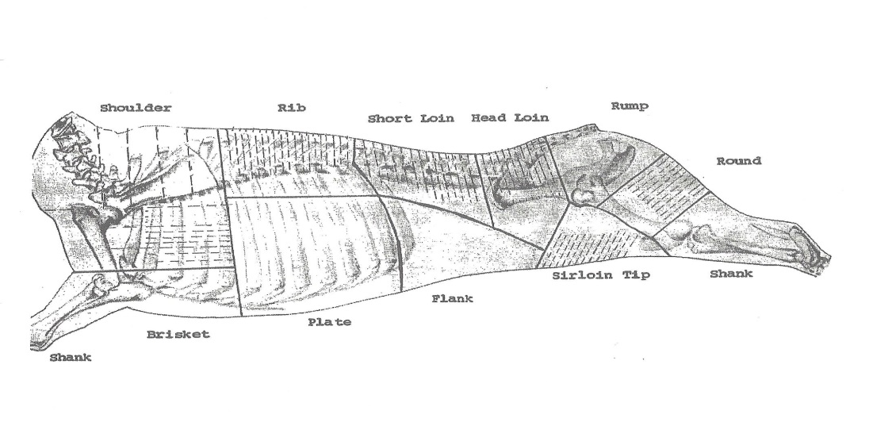

All cuts of big game should be boneless, please no ground meat. Ideally, game birds should also be de-boned. Fish should be provided either frozen in water, or as vacuum packed and frozen.

**GUZZLERS:** Larry Martin

The recent fires in the region have destroyed or severely damaged several guzzlers near Prosser. Three guzzlers were destroyed by fire and three more were damaged. In addition, there are many other guzzlers that are in need of repair/maintenance. Two tanks with tops were located at Windmill Ranch WMA and were donated for the guzzler program. It was brought up that the budget contained $500 under Use of Funds that was to be split between the guzzlers and wood duck boxes. As a part of the guzzlers program, the Board was informed that the local representation of WDFW would prefer direct purchase of materials in lieu of donations to the general WDFW funds. Expenditures in this manner will allow for RR&GC funds to be spent in a more efficient and directed manner.

A guzzler repair effort was undertaken on a unit that was destroyed during a fire this past summer. One of the tanks from the Windmill Ranch was used. To help prevent a future problem such as this, a metal frame was used to support the water collection roof, and the fiber glass tank was better insulated with dirt. Club members Larry Martin, Ron Ruth, and Dave Myers along with one hard working non-member accomplished the project.

**SALMON IN THE CLASSROOM:** Gene Van Liew

The 2015 Salmon in the Classroom program has suffered considerable budget reductions. The Salmon Summit and Classroom activities will continue. However, the biggest hit will be to in-classroom dissections, where Benton Conservation District personnel will no longer be available; dissections will be performed by individual teachers, with RRGC assistance if requested. The BCD will provide training to teachers to help them carry on. Gene has committed to assist with delivery of supplies; however tank setup and tear down will have to be done by individual teachers. These teachers are dedicated individuals, but this additional burden may tax them beyond their ability to keep the program going. Additional Rod and Gun Club volunteers may well be needed to provide setup and tear down assistance.

**GAME RECOVERY:** Chris Mosher/Larry Martin

Larry Martin responded to a 4:00 AM call from the WSP about a deer that was hit in Richland off of I-182. Larry skinned and quartered the deer on location, then took the quarters home where he deboned the carcass and subsequently delivered the meat to the Union Gospel Mission. Thanks for your hard work.

**RINGOLD HATCHERY WORK PARTIES:** Dale Schielke

Thanks to all the RRGC volunteers that assisted WDFW at the Ringold Fish Trap over the last couple of months.  The returning fish numbers have dropped off to the point that additional help at the trap will not be needed for the rest of this year.

WDFW is tentatively planning to relocate steelhead fry to the 5 acre rearing pond on December 9th, contingent upon a fish health inspection scheduled for December 8th.  A couple of volunteers could be used if the relocation is approved.  Volunteers interested should contact Dale Schielke 375-0183 for details/registering who will coordinate last minute notification.   If other projects at the Ringold Hatchery develop we will advise members via the newsletter and at meetings.



**Lyme Disease:** Paul Kison

It was reported to the club that a local hunter contracted Lyme disease from a tick encountered while hunting deer in the Republic area. Club members are advised to take care while dressing their kill to avoid the deer ticks which are the vector by which the disease is transmitted. Lyme disease is a serious and long-lasting ailment that often mimics rheumatoid arthritis. Prevention is the best approach; tick repellant can go a long way toward preventing the infection.

**Thanks:** Dave Myers

Thank you to all who helped out with Sage’s veterinary bill that resulted from her being bitten by a rattlesnake during the September youth hunt near Mesa. She is doing well at this time, and has been able to participate in several hunts since the incident. For those of you who also hunt in rattlesnake habitat, it is possible to get an annual vaccination for your dog. The vaccination does not totally take care of a bite, should it happen, but it does greatly reduce the impact of the venom.